

**TEAM REPORT**

Ron Berg

Jeff DeSpain

Sohaib Hegazy

Mark Zovne

4/23/2015

Contents

Executive Summary 3

Introduction 4

Team Members 5

Mark Zovne 5

Ron Berg 5

Jeff DeSpain 6

Sohaib Hegazy 6

v0.1 7

v0.2 9

v0.3 11

v0.4 14

v0.5 16

v0.6 19

Technology Stack 21

Testing 22

Project Future 22

# Executive Summary

The animal adoption and rescue community is a steadily growing number of people who want to lend their voices to saving animals from abuse, starvation and euthanasia. They tend to be rather ardent in their beliefs and close knit when it come to the social aspect of the adoption community. The Loving Paw is a small Arizona based business that is trying to spread the word about everything that can be done for animals through their unique, custom made products as well as an interactive website that encourages community discussion and provides interesting news pieces. Additionally, part of all of the proceeds are donated to charity in order to provide the animals they care so deeply for a better chance.

In order to accomplish their goal, The Loving Paw needed a better web presence. Though the owner, Alexis Enright, did her best to create a site using the GoDaddy website builder, she felt that should would benefit from fresh eyes with a bit more technical knowhow. She needed to the site to be easily managed though, so the Shopify e-commerce specialized service was chosen to build her a dynamic site quickly that should use and manage without knowing how to write any code herself.

Work began on the site early in the semester in order to not only maximize the number of features that could be implemented but also to give ample time for site testing and marketing the new site in an attempt to drive revenues for Alexis. New color schemes were selected and reselected based off of customer and client feedback and features were added to the site based on what things that were discovered over the course of the project. The site grew from its original, simplistic e-commerce beginnings to a social experience that customers could participate in and buy the items that they thought would best suit them.

Once the site was completed, the marketing for it began keeping the name The Loving Paw. Using the same domain name, the site was able to increase its initial traffic dramatically as well as provide an initial increase in sales for Alexis. Using an agile approach, the site was continually improved upon and tested as issues were identified. This allowed the site to be improved upon by the time of the project close whereupon the site files, custom changes, how-to guides and analytics data were all turned over to Alexis for her to peruse and use to grow her business even further.

# Introduction

The Loving Paw is a small business dedicated to designing and selling products that will raise awareness about animal adoption. Run by Alexis Enright out of Scottsdale, Arizona, the business sells t-shirts, custom dog tags and other animal adoption related products and donates 10% of the proceeds to the 501(3) non-profit organization Athletes for Animals. The business is run on a user built site hosted on GoDaddy and Alexis designs and creates her products out of her house. In addition to her online orders, Alexis travels the country and attends various pet related events in order to help spread the positive message about animal adoption (as well as sell a few more products). Due to her efforts, The Loving Paw has been steadily growing over the past few years and Alexis is ready to start expanding the business into more professional territory.

The work Alexis needed done stemmed from her lack of technical knowledge when it comes to website design and e-commerce strategies. She has had personal experience with animal adoption and the benefits that it provides and came up with an idea a few years ago of selling hand made products that help support her cause. She donates part of her proceeds to the non-profit organization Athletes For Animals and has been steadily increasing her sales by attending pet adoption events as well as through her current website registered and hosted by GoDaddy. Given the steady increase of sales over the past few years however, she has decided that her current site is no longer enough for her needs and wished to consult with us for a better design and functionality of the site that will allow her to increase both her revenues as well as her voice in the pet adoption community.

Our solution to the project involved doing an analysis of the current Loving Paw website to identify its strengths and weaknesses and use those to develop a new site using an ecommerce service that would allow her to easily manage the site once the project is completed. After researching several different options, we presented her with our findings and recommendations for Shopify, GoDaddy with enhancements or a site design built from scratch. The client elected to use Shopify as it allowed for the most dynamic web site design while still being easy to manage for someone who isn’t technologically inclined. As part of the site design, we also decided to do several marketing pushes for her while using Google Analytics to collect behavior and sales patterns of the site visitors. This would be presented to client at the end of the project along with recommendations as to where and how she should be reaching out to new potential customers to both increase revenues as well as raise awareness for a cause that she believes in.

# Team Members

## Mark Zovne

Mark will be graduating May 2015 from Arizona State University with a Bachelor’s of Science in Computer Information Systems. He has eight years of previous computer repair experience and four years of retail store management. His key skills include Visual Studio, C#, SQL, HTML, CSS, Java Script, and PHP. He enjoys learning and is always ready to tackle new challenges.

Mark has lived in many cities including Bangkok, Thailand. In 1992, his father moved his family consisting of his mother and two sisters to Phoenix, Arizona.  Mark loves Phoenix, and enjoys hiking the numerous trails the city has to offer.  He also enjoys reading and hanging out with friends.

## Ron Berg

Ron has lived in Arizona for over 30 years and has watched it develop around him. After graduating from Gilbert High School in 1997, Ron attended the University of Arizona for a year before realizing both that he had no idea what he wanted to do and that he hated Tucson. Ron moved to Tempe and got a job doing credit analysis which he found he rather enjoyed. Four years and two promotions later however, he realized it was time for a change. Being a lifelong movie fan of all shapes and sizes, Ron decided to try his hand at independent film making while he was still young enough to afford being broke. He was able to make contacts with some people in the local film scene and landed roles in 4 feature length films and even more short films. Though Ron is proud of these films, he refuses to comment as to the quality of them. Around this time, Ron started to feel restless, as though a lifetime of bartending to pay the bills wouldn’t be enough for him (filmmaking, shockingly didn’t pay much).

Ron enrolled back in school at Arizona State University in August 2011 as a Computer Science major before making the shift to Computer Information System after realizing that he had no interest in designing microprocessors or operating systems. Finding this to be much more to his liking, Ron is now set to graduate in May 2015 and begin a job as a software engineer at American Express. In his free time, Ron enjoys going to the movies, reading a horror novel and spending time with his family. He can often be found schooling his 11 year old stepdaughter on the basketball court.

## Jeff DeSpain

Jeff is an Arizona native, born and raised in the Gilbert area. He will be graduating from Arizona State University in May 2015 with a degree in Computer Information Systems and Accounting. Jeff’s information technology background consists of large amounts of work with VBA in Microsoft Office while working for ASU Stores as a student, as well as .Net development and procedure creation and documentation in the IT department of the Arizona Public Service Company as an intern. Jeff is passionate about software development.

Jeff has always lived in Arizona, except for a two-year stint in which he served a mission for the Church of Jesus Christ of Latter Day Saints and lived in the Dominican Republic and Aruba in Caribbean. Jeff believes that the two years he spent on his mission shaped the way his life is today. He is married with a little girl on the way and enjoys spending time with his family, participating in his church, watching sports, and programming.

## Sohaib Hegazy

After moving from his birthplace in San Diego, California, Sohaib has been living in Arizona for over a decade. Through experimenting with various start-ups during and after graduating High School, Sohaib found a passion for work using technology to build businesses. He attributes his successes in his earlier startups, as his motivation to pursue a degree in Business. Upon graduating High School in 2010, Sohaib pursued and attained an Associate Degree in Business in 2013.

Presently, Sohaib is a Senior Undergraduate Student at Arizona State University’s W.P Carey School of Business, pursuing BS degrees in Computer Information Systems, and Supply Chain Management. He has experience in the local Arizona Real Estate Industry having been a licensed Realtor in Arizona for nearly four years. Sohaib’s upcoming goals include utilizing skills obtained through past CIS courses to pursue and develop a successful career in an IT related field. Sohaib’s hobbies include reading books, watching Shark Tank, and spending time with family and friends, and working with his family’s Real Estate Brokerage.

# v0.1

We made contact with Alexis immediately after the group decided on The Loving Paw as our project. We were able to set up a meeting with her the weekend after the project selection. Unfortunately, due to other commitments by both the client and team members, the meeting was only able to last 90 minutes to do preliminary requirements gathering. We sat down with Alexis to discuss what her business does, is it a profit or non-profit organization, walk through her current site, find out what technology she is currently using to register and host her site and discuss further what she was looking for from us.

Alexis’ message to us was that she was looking to start expanding her business from a home garage operation to a legitimate small (primarily) business but that she didn’t like her current site hosted by GoDaddy and designed by her with GoDaddy site making tools. She also made very clear to us that she is technologically illiterate when it comes to designing things online, even with site building tools. On top of this, her site had designed piecemeal using GoDaddy for hosting, WordPress for her blog, and Etsy for her shop. The Etsy shop in particular was frustrating for her because it redirected from The Loving Paw site to Etsy itself which has some stifling policies for growing businesses. From our discussion with her, we determined that what she wanted was a brand new site with professional looking design that has centralized features (i.e. shopping cart featured on the site instead of a redirect), and the same features as her previous site. In addition to this, the site had to be easy to manage and edit for someone who has no knowledge of computer code. Most importantly however, due the small size of the company, the web site needed to be completely functional and ready to use by the end of the semester as there was no IT department that would be able to take what we had completed and improve upon it.

With these requirements in mind, the team sat down to discuss our options. After a robust two hour discussion in which every team member contributed quite a few ideas, the following options were decided on as potential choices for our client.

1. Remain with GoDaddy/Etsy/Wordpress. Though this was almost explicitly what the client said she DIDN’T what, a financial analysis revealed that at the level she was at, it would be the most cost effective decision to stay with the format she had.
2. Sign up for Shopify and let us design the site and site functions for her. This option was more in line with what the client wanted and provides easy to use, “out of the box” tools that would make it easy for the client to maintain and manage once our part of the project is completed. Additionally, the site functions are centralized with many available apps to add additional functionality to the site if she decides upon it later. Though this was the least cost effective option for her at this time, her goal of growing of her business means a site on Shopify will eventually come more in line with her goals if she is able to increase her sales.
3. The third option for the client was to allow us to design her site from scratch. This idea was easily the most cost effective as it would cost very little aside from site hosting and domain name registration and provided the most potential creativity as we wouldn’t be restricted by the paid service site building tools. The risk of this option is that there was no guarantee that we would be able to complete the site with the necessary functionality by the end of the semester.

We presented the clients with this option and after some discussion, she elected to use Shopify for her site hosting and designing needs. This was primarily due to the fact that a centralized site that would be easy to maintain and would be completed for her was the primary goal over cost and potential creativity. Understanding that the project that she needed would be completed relatively quickly, we also decided to start brainstorming ideas for analytics campaigns for her new site to try and provide some extra value to the client for her future endeavors.

# v0.2

Release v0.2 started with us reconnecting with Alexis to get a better feel for what kind of site design she was looking for using the Shopify tools. We presented her with numerous sample sites using Shopify for her to get some ideas for what she wanted to do. She came back to us saying that she wanted a “rustic modern” feel for The Loving Paw that was gender neutral and gave the site a down to earth, natural feel that she felt would appeal to her customers.

We began by going through the ready-made Shopify themes to decide what templates would allow us to meet the goals of The Loving Paw the best. We eventually settled on the “Minimal” theme which initially looked very much like it sounded. We selected this theme as we thought it would give us the most flexibility in deciding how we wanted to style the site. We quickly found out though that though the theme probably has good functionality for some organizations, for us it was just dull. Attempting to add colors or background images ended up looking cheap and tacky. We attempted using the client’s suggestion of using reclaimed woods phots as a background image which did provide quite a bit of aesthetic appeal but unfortunately gave the site a bit of an identity crisis. After several days of working with this particular model, we decided we needed to come up with something different.

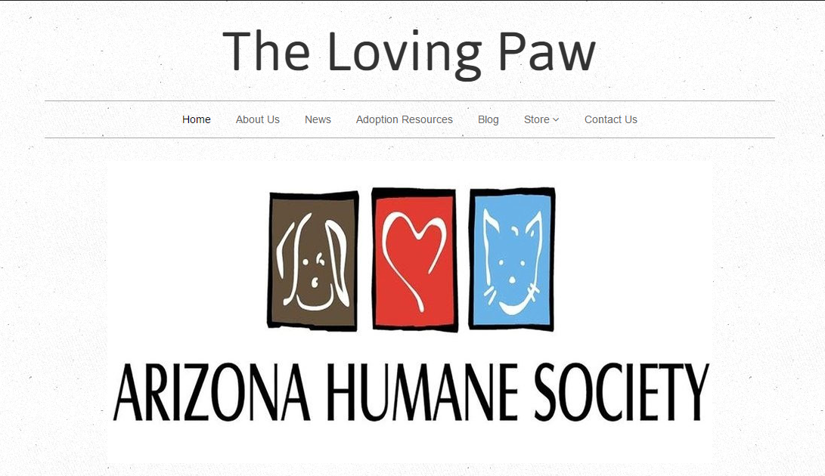

Minimal Theme

We ended up finding the “New Standard” theme that seemed to have a little more of what we were looking for, particularly in regards to a shopping cart that kept a running total of the user’s purchases through the entire site. We decided to use a parchment style background to take some of the harsh white glare off of the background. We began work on importing all of the information, products, blogs and inventories from her Go Daddy site to the new Shopify site and tried to style it in a way that would give the site some personality. Unfortunately, despite the better suited template design that we had going, we still couldn’t find a way to add color or images to the site without it quickly becoming over stimulating and gaudy.

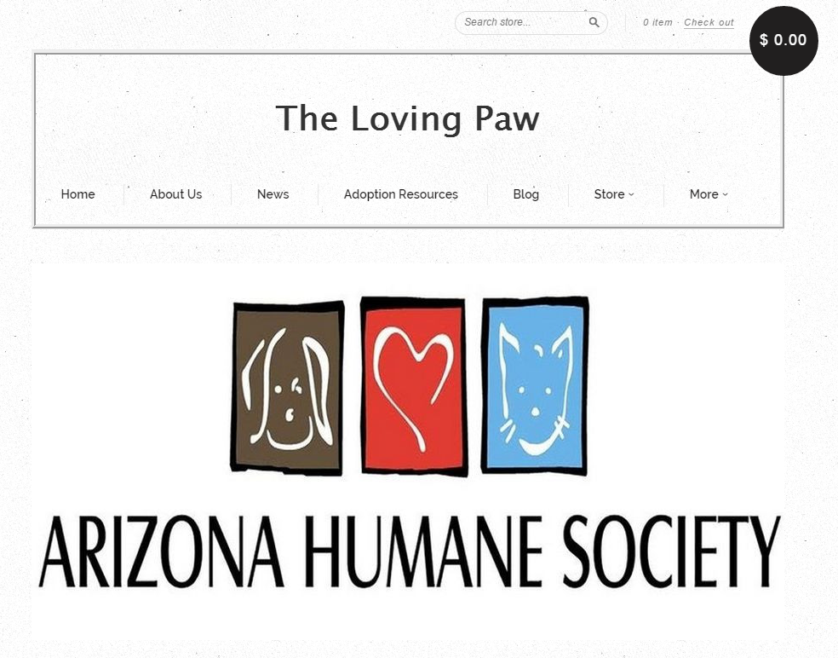

New Standard theme

After reviewing the site once the basic functionality was built, we considered attempting to build a theme from scratch using Shopify tools. Because we had encountered at least one fundamental problem using any theme we had previewed or worked with, we thought that perhaps building one ourselves would allow us to create a theme that would exactly fit needs of The Loving Paw instead of just mostly. However, after trying to find ways to recover the time that we would lose with this approach, we decided that it would be too labor intensive and may prevent us from finishing the rest of the necessary work for the project. Though we had concerns about the visual appeal and lack of the material on the site, we decided it was a good Minimum Viable Product to begin user testing and feedback on. Using that approach, we could figure out if our concerns were warranted or if we were essentially worrying about nothing.

It was also in this time period that began brainstorming about what we would want to do for the marketing and analytics portion of the project. We decided to go with Google Analytics as it provided a no-cost, user friendly approach that we could use with (and eventually turn over to) our client. For testing purposes, we put the tracking code into the Shopify site so we would be able to see the results of our upcoming user feedback tests. In addition, a separate tracking code was added to the existing Go Daddy site to establish a baseline metric to work off for comparison when the Shopify site goes live. We also began discussing ideas for email, paid and social media campaigns in the upcoming weeks.

# v0.3

Our plans for release v0.3 were to get client feedback and go live with the site so that we could start Analytics testing sooner rather than later. We ended up starting off a bit rocky however as our meeting with Alexis to discuss her feedback for the initial site design and preparations to move forward was cancelled due to illness. Further attempts to set up the meeting were also derailed as the client’s illness extended into the next two weeks. This ended up being a blessing in disguise though as it forced us to do user testing with random end users instead of focusing on the client. Primarily our feedback was solicited through friends and family who were able to view the site with fresh eyes and offer us insights that might have otherwise gone unnoticed.

The feedback we got was almost universal on both the likes and dislikes of the site. The people that looked at the site enjoyed the navigation aspects of the site, finding it easy to use. This was good for us to hear as it meant we didn’t need to focus as much time on the functionality of the site. Additionally, our feedback sample liked the accessibility and look of the site cart, commenting on the pervasiveness of throughout the site using the theme we had. With this cart, the total of the customer’s purchases would be visible and totaled from any page of the site so they could see what they were going to spend without constantly having to go to a cart page.

The opportunities for improvement we ascertained from our feedback users were even more helpful. The most common comments that we got from people was that the logo and the site itself was bland. Since we had started with a slate colored theme with minimal design additions, we decided that was a good place to start taking a closer look. One of the first things we realized that we were four men attempting to make a site designed for what we hypothesized was a primarily female audience. This led us to taking a different approach by asking what the users thought would be a good color scheme and how would they go about doing it. In addition, we leveraged help from several contacts who had previous web design experience. We attempted to salvage using the theme we already selected from Shopify using the new site color scheme suggestions and logo design, but were unable to as every theme has its own individual limitations. The team then studied new theme ideas that would allow us to achieve the more flexible color scheme and logo design that we desired and eventually selected the “Supply” theme and moving away from the “New Standard” theme. We were quickly able to put together a new site that utilized a nude and maroon color scheme and a logo that we thought would appeal to the customer base Alexis was going for. While we lost the original cart that many people liked, the new cart used an Ajax functionality that allows customers to view their whole order from a pop up screen as opposed to seeing a running total throughout the site. The new feedback that we received from the users that we showed the site to was positive with almost everyone remarking that the new site was much more pleasing to the eye and showed definite improvement in drawing the user in.

The second feedback bit that we got was that people didn’t have much idea of what The Loving Paw is or what they do. The original site had some very basic functionality that we were able to import to the new site with ease, but unfortunately didn’t say much to what the The Loving Paw mission was.

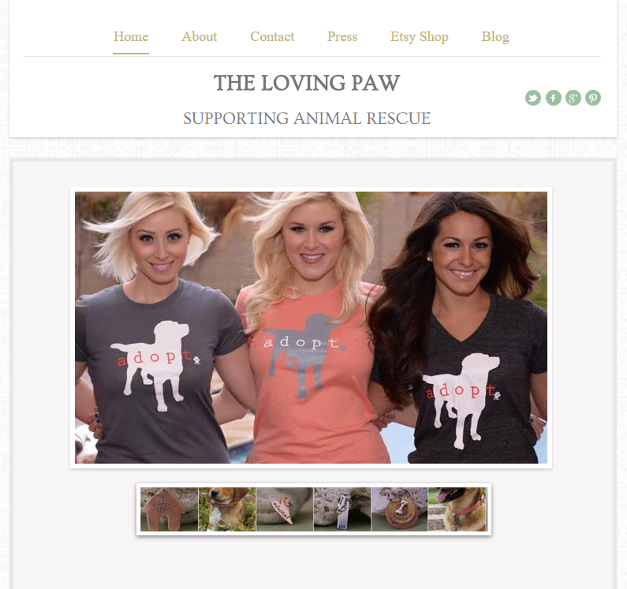

Original site

One of the things that we noticed in getting user feedback was that some people wanted to see more pictures of animals and some people wanted to just donate without buying anything. This led us to the realization that what people were looking for wasn’t an e-commerce site that promoted pet adoption, but a social community site that promoted pet adoption and had an e-commerce feature for users to buy unique products while getting news stories, learning about upcoming events or linking to similar organizations that promote pet adoption. As such we added “news and events” and “adoption resources” pages to the site in an attempt to give it more for the adoption community to experience at The Loving Paw and ideally lead to additional sales rates from satisfied users of the site.

The reaction to the new site designs was overwhelmingly positive with most people commenting on liking the new color designs and site functionality. We decided to use this design to meet with the client once she was back to health and ideally go live with by the next release. This would also allow us to begin work on the analytics and marketing portions of the project that would permit us to begin the validated learning process.

# v0.4

Release 4 saw the project continue at a slower than anticipated pace as the client’s medical condition threatened to sideline her unpredictably for the foreseeable future. Concerned about her health, but also wanting the project to gain some traction back, we decided the best course of action would be to continue the project doing meetings virtually through Google Hangouts. Though this approach would hinder our ability to train the client properly on how to manage and maintain the site once our work was completed, we felt that it was important to make continual progress in order to assess what would work when the site was live and what would need further work. We were eventually able to have a meeting with the client once she was feeling healthier at which point we were also able to get her reactions and feedback about the site as it was. She responded very positively to the content based additions to the site that she felt gave it some additional breadth and created a more robust experience for the customer. She also noted that the overall look and feel of the site was much more welcoming and professional than her previous efforts had been.

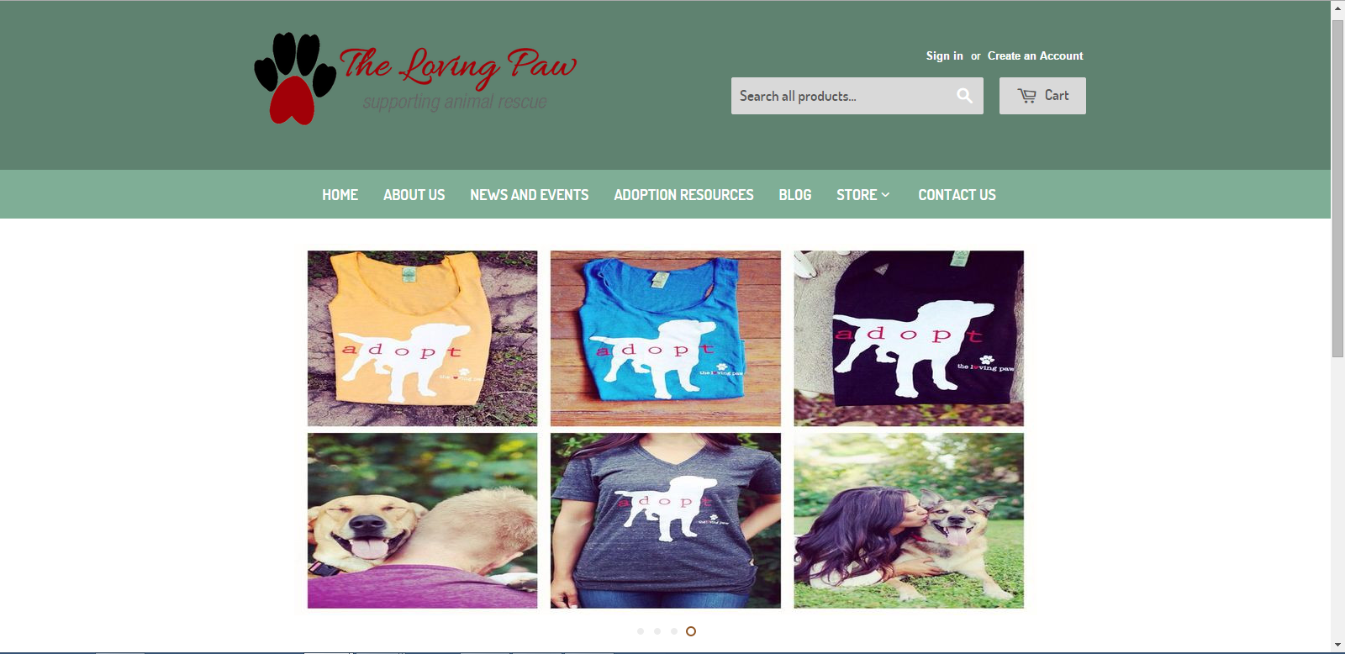

Alexis’ criticisms of our design were primarily in the form of the color scheme and the new site logo, which surprised us. The original color scheme we used were shades of red that we felt gave the site a more neutral feel, but the client just didn’t like the feel of them. We spent some time working with her on what she was looking for and eventually decided on shades of blue and green that presented a more calming feel throughout the site, but perhaps went away from the original rustic feel that she had been looking for. Her comments of the new logo were what really surprised us however. Everything we had learned thus far had indicated that site clientele was going to be primarily female and we designed the new logo to reflect that.



Original Logo



Redesigned Logo

The client was insistent that her site had a fairly equal draw of men and women and regardless of that, didn’t want the site to be overly feminine as it would potentially turn away some people who may otherwise be more involved with the site. We advised her of our customer feedback regarding the feedback we had received thus far regarding the logo and she agreed to leave it as it for the time being, but with the option to change it back to the original logo at her discretion. We concluded the meeting with her with several new ideas to work on and some definite direction to move in to finally make the site live for new customers and begin our marketing campaigns.

It was also during this time that we took a look at the project from its inception to the point we were currently at so we could get a proper idea of how much work had been completed. It also gave us an opportunity for us to decide what was and was not working as a team and learn how to be more efficient moving forward. We reflected largely on the organic growth that the project had experienced from an out of the box solution for a primarily e-commerce site to a proprietary/custom coded hybrid site that focused on engaging the animal adoption community through news and opinion pieces that invited social interaction among the participants. The e-commerce portion of the site certainly still existed, but it was no longer the focal point of the site. This would be our approach as we worked towards going live and being our analytics research.

# v0.5

Version 0.5 of The Loving Paw project began with us consulting one last time with our client and putting the finishing touches on the site so we could go live. We were able to import Alexis’ inventory from her Etsy site, which the client also commented that she would like to keep. This posed a potential problem as we did not have access to her Etsy sight to see what was selling and how many orders she was getting from her old store. However, we decided to go live for the new site anyways in order to drive some traffic and ideally raise some revenues for Alexis as well. Finally, after all of the work put in by the team, we went live with the new Loving Paw on March 19, 2015. This involved simply changing the DNS settings on her GoDaddy Account to point to the IP Address of Shopify’s servers.

We had several different strategies we wanted to employ to drive traffic to the site and ideally drive sales up. We had discussed the possibility of doing an email campaign using Mail Chimp, but that idea quickly fell apart when we realized that we had no easy access to a mailing list. Running with the new social theme of the site, we decided instead to focus on social media outlets such as Facebook, Twitter and Reddit. We discussed the order of how we wanted to approach the marketing pushes in a sense of should we start with a smaller audience to slowly roll out the site and identify problems or push to a larger audience to get sales as quickly as possible.

Ultimately, we decided on pushing to a smaller audience to start with as it would give us a chance to identify any lingering problems with the site as well as the fact that the client’s inventory was too thin to handle a large potential influx of orders. The best strategy for this was to push to our personal Facebook accounts. The reasoning behind this decision was that it would be a smaller total audience than some of our bigger audiences and it would give us the most random sampling of people to test our two main hypotheses: that social interest would drive traffic to the site and that pure volume would drive sales up.

We added the Google Analytics tracking code to the new site and all four of the team members put posts up at the same time informing people what the site was and what it was about as well as providing a link to the new Loving Paw. Our first day results were mixed.

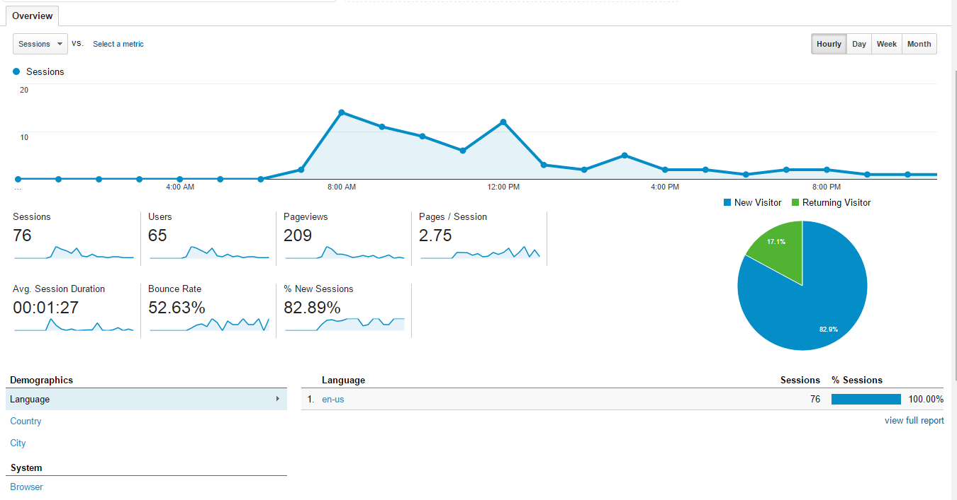

Day 1 Analytics overview

We saw somewhat higher traffic than we had anticipated with 65 users logging onto the site throughout the day and 82.89% of the traffic being new users. The page views per session ended up at 2.75 which about what we were expecting given the limited content. However, the average session duration was lower than we wanted at 1:27 and the bounce rate was at 52.63%. We were able to ascertain from the date however, that some of the site hits were from foreign web crawlers that simply go to the site and then move on. This leads to an artificially high number of users and bounce rate and an artificially low average session duration. We applied a filter to the site to block the most active crawlers which brought our traffic results more in line with what we expected. Additionally, we noticed that people were sharing the site on their own Facebook pages, which led to hits from around the country. Although the traffic was definitely heavier locally, we were able to see people looking at The Loving Paw from over 40 other cities throughout the first week of going live.



First week results by geographic location

While we were excited about these initial results, we didn’t see any initial sales on the first day. Using Shopify’s e-commerce based analytics, we were able to see that a few people had added things to their carts, but abandoned them upon checkout. A manual test of the site turned up that the e-commerce settings were still set to testing mode. We quickly rectified this before our second push and verified that orders could actually be made from start to finish. Upon the second push, we saw similar results to the first push. People were visiting and sharing the site with some people adding items to their carts, but no one actually buying. This was rather discouraging and made us start leaning towards invalidating our second hypothesis that volume would drive sales. However, we theorized that this may be due to the fact that most of the site visitors were probably friends and family that didn’t have much interest in buying pet adoption products. With one partially validated and one partially invalidated hypotheses, we could redirect our coming marketing pushes. We would continue to use social media platforms but with a more pointed approach towards finding people that more directly interested in pet adoption and rescue. Additionally, future campaigns would be more aggressive, perhaps with daily postings instead of once or twice weekly.

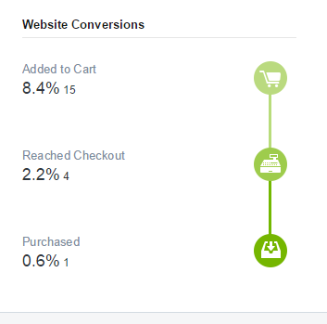

First week E-commerce results using Shopify Analytics

While we had been sharing these results with our client, we didn’t hear much back until the first week of the marketing pushes was done at which point we were informed that she had a seen a surge in her Etsy store sales over the previous week. Because we didn’t have access to the Etsy store, our data for those sales was limited, but we were able to match at least a few of the sales to our marketing pushes. This meant we would have to again redirect our line of thinking. We decided to still go towards the pet adoption crowd as the products we were trying to sell appealed to a niche market, but we would perhaps be a little less aggressive and carefully monitor the site activity and sales to make sure that the client didn’t not get overwhelmed with orders that could potentially cause stock outs or unfulfilled orders for any reason.

# v0.6

Release 6 focused on us testing the site and beginning preparations to turn the project over the client. Testing was done using Selenium and to make sure that the site work as we intended it to. Because we were using predesigned software, we didn’t have many worries that the site would crash, necessarily, but we did have some concerns that the site would function as planned due to the custom products sold on the site. Our initial plans revolved around creating scripts to both recreate the site from scratch automatically as well as one that would solve custom inventory problems.

The first script designed to recreate the site was initially created for the client to be able to rebuild the site from nothing if necessary. Though a significant amount of time was put into this endeavor, it was eventually decided that trying to learn Shopify’s proprietary code in the amount of time that was available to us may end up being unfeasible. This was disappointing in the terms of what we wanted to accomplish with the project, but ultimately we feel it was the best choice.

The second script was started after identifying problems with the custom inventory issues. We attempted to rectify the inconsistencies with the custom products by introducing a script that would pull the correct inventory numbers from the correct variants and deduct the correct amount when a custom product was ordered. Similar to the previous script attempt however, we were unable to get around the proprietary code that Shopify uses. During testing, the script would work sometimes but not consistently enough for us to feel comfortable deploying it to the live site. This was especially true given that the client may experience issues with it when her customers place orders and we would be out of time to adequately fix it. The script was abandoned and in its place we removed the Ajax cart from the site and created a cart page that rectified some of the issues of pulling from the correct inventory. Additionally, we alerted the client to the issue and added instructions to the site for how to order items properly.

It was also during this time that we received some final feedback from the client as we prepared to begin closing the project. She decided that her original logo better fit the image she wanted to portray for the site, feeing that the new logo had too much of a gender bias. She also had some concerns about the banners on the site giving the impression that there was an official affiliation with some of the groups we had listed in the adoption resources section of the site. To rectify this, we placed a banner over the slider image informing guests to the site that they will be taken to the Adoption Resources page and not the page of the image they are clicking on.

Though we had hoped to accomplish more work during this sprint, the constraints of the project limited what we were able to successfully achieve. However, we (and more importantly the client) were happy with the site that we deployed. We felt that with the time remaining on the project, introducing too many new elements to the site that may potentially break it would be a bad idea. Accordingly we spent the remaining time of the project cleaning up the minor issues on the site to provide the client and her customers the best experience possible.

# Technology Stack

As previously detailed, The Loving Paw site redesign was done using the Shopify web service. Though we discussed writing a website from scratch using an application such as Bootstrap, one of the necessary criteria for the client was that the site had to be easily to manage and easy to modify as she has little to no technological experience and little to no desire to learn about code. Shopify uses a combination of HTML, CSS and Liquid code for its site designs. Liquid was developed using Ruby on Rails and allows store designers to design their sites the way they like while also allowing Shopify to maintain their internal servers.

Given that we were using “out of the box” software, we did not have to code the site from scratch. Though this made for an easier initial site design, it also created some constraints with regards to implementing some of the features that we wanted. While many of the predesigned themes had some of the features that we wanted, we were unable to find one that had all of the features that the client had requested. We explored both purchasing a premium theme that would allow full implementation of the features we wanted as well as building a site from scratch. Both of these options proved to be not viable however. We didn’t want to present additional financial requirements on the client unless absolutely necessary and we didn’t have the requisite amount of time to learn how do design a theme that would could guarantee would be finished in time and allow easy management by the client. Accordingly, once we selected the theme that best fit our needs, we decided to modify the pre-written code to better implement our requirements.

Once the site was built, we turned to a marketing campaign to better understand who The Loving Paw’s customers are. We decided to use Google Analytics as our analytics platform primarily because it is relatively easy to use, requires no local software installation and because it is free for small businesses to use. In addition, Google Analytics offers hundreds of metrics and features to search by that rival many of the other AAA brands available today. It also offers a live review of site activity, tracking users and the pages they visit on the site as they view them. This could allow the site owner to offer flash sales or personalized offers to her customers as she felt. We were able to get geographic location information as well as information such as ISP, Operating System, Browser and even some user interests based on other web searches. We felt this would benefit the client greatly as she would be able to gain greater insights into her customer base than ever before.

# Testing

One of the greatest challenges that the group faced with the project was how to properly document the processes taken to create the Shopify site. With so much of the Shopify site being point and click software, it was rather easy to create the site skeleton and site pages, but it was difficult to document because there were so many settings and customizations that had been changed.

The team did not have access to all of the site source code, so the problem couldn’t be solved by simply providing all of the source code. That meant that the team would have to try to look either for an automated solution to the problem or to document the customizations by hand.

One of the team members began researching the feasibility of creating an automated script that could actually use an automated web browser to click through Shopify admin panel and select all of the site customizations automatically. After research, the automation project began by using the Selenium Web Driver in Ruby. This process went well, although it was time consuming. The project soon moved into .Net using Selenium in C#.

Before the script was finished, the team member hit a road block and then soon needed to devote his time to creating some automated test cases before devoting more time to the automation script. During this time, the team discovered a Shopify manual for purchase online that could replace the automated script. It made more business sense to purchase the manual rather than invest more time in the automation script, so the team made the decision to purchase the manual and abandon the automation script.

# Project Future

The site will now be in custody of Alexis. The site went live several weeks before the completion of the project window. It gained some views after the initial release due to a social media push on the part of the team members. If the site is going to have steady traffic in the future, it will likely require more social media pushes and advertising from the site owner. Much of the initial traffic for the site will probably have to come from converting users currently using Alexis’ Etsy site to using the new Shopify page.

The management of the business will need to be moved from the Etsy site to the Shopify admin site as well. This means that at some point in the future, if the Shopify site is used, then the Etsy site will need to be closed and fully migrated to the new Shopify site from the project.

The group provided Alexis with an official Shopify user’s guide to aid her in any site maintenance in the future. It doesn’t appear that there will be any major structural or functional changes to the site in the near future. Alexis’ goal seemed focused mainly on having the site completed by the time the project was finished. Minor customizations for aesthetics, such as color and font changes, will be easy to perform for Alexis because of the point and click software available to her through the Shopify Admin Panel of her site.